H.T.NO:2303A51706 BATCH 28
TASK 1:
Prompt:
Implement and compare Quick Sort and Merge Sort algorithms for sorting a large dataset of student records (each record containing Name, Roll Number, and CGPA) by CGPA in descending order. Generate 10,000 to 100,000 student records with random data. Measure and visualize the performance of both algorithms, then display the names, roll numbers, and CGPA of the top 10 students from the sorted list.
Define Student Record Structure and Generate Data Subtask:
Create a class or dictionary structure to represent student records including Name, Roll Number, and CGPA. Generate a large dataset of student records (e.g., 10,000 to 100,000 records) with random data for testing.

Reasoning: First, I will install the Faker library, which is required for generating random names. This should be done in a separate cell before the main code block.
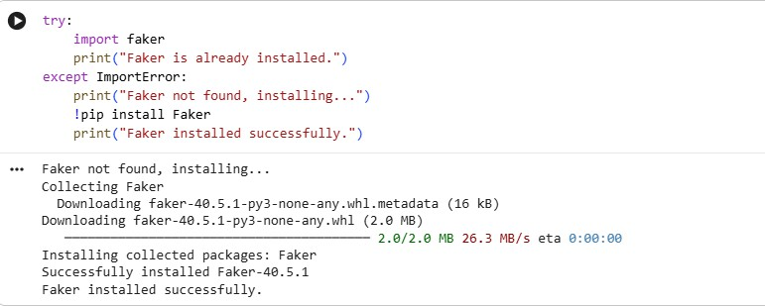

Reasoning: Now that Faker is confirmed to be installed, I will define the Student class, import the random module, create a Faker instance, and then generate the specified number of random student records, storing them in a list and printing the first 5 to verify.

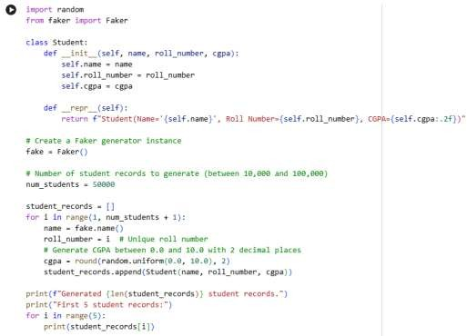
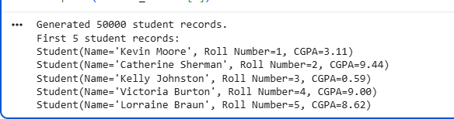

Implement Quick Sort Subtask:
Implement the Quick Sort algorithm to sort the generated student records based on CGPA in descending order. Ensure the implementation is robust and handles various data distributions.

Reasoning: I will define the partition helper function for Quick Sort, which will arrange elements around a pivot based on CGPA in descending order.

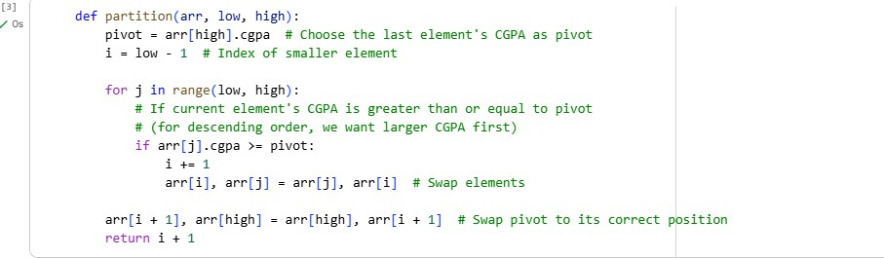

Reasoning: Now that the partition helper function is defined, I will define the
main quick_sort function that uses partition to recursively sort the student records in descending order by CGPA, as per the instructions. Then, I will test
the quick_sort implementation by applying it to a copy of the student_records list and printing the top 10 sorted students to verify correctness.
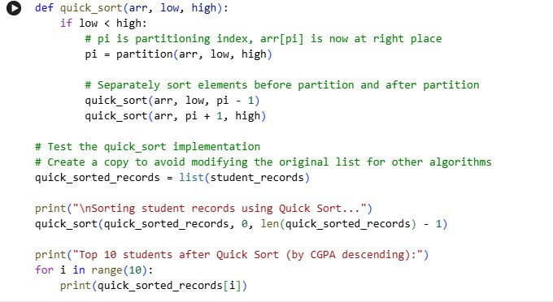

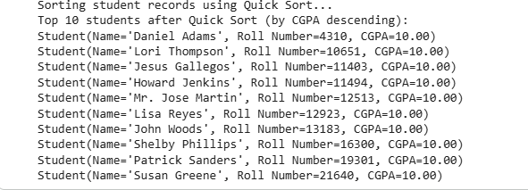

Implement Merge Sort Subtask:
Implement the Merge Sort algorithm to sort the generated student records based on CGPA in descending order. Ensure the implementation is robust and handles various data distributions.

Reasoning: I will define the merge helper function. This function will take two sorted sub-arrays and merge them into a single sorted array. The sorting order will be
descending based on the students' CGPA, as specified in the problem statement.

Reasoning: Now, I will implement the merge helper function, which is a crucial part of the Merge Sort algorithm. This function will take two sorted sub-arrays and combine them into a single sorted array based on CGPA in descending order.
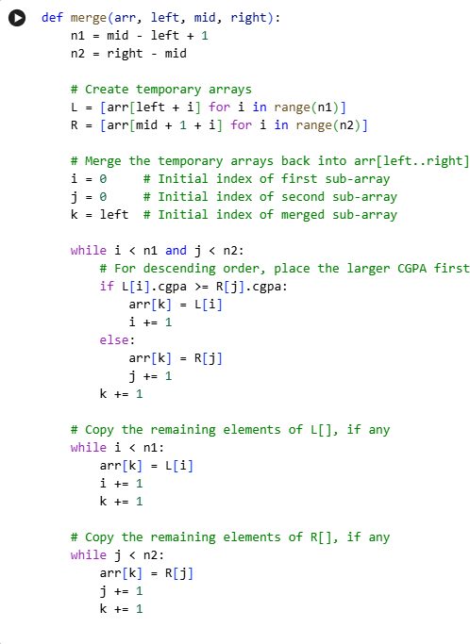

Reasoning: Now that the merge helper function is defined, I will define the
main merge_sort function that uses merge to recursively sort the student records in
descending order by CGPA, as specified in the subtask instructions. Then, I will create a copy of the student_records list, apply the merge_sort to it, and print the top 10 sorted students to verify its correctness.
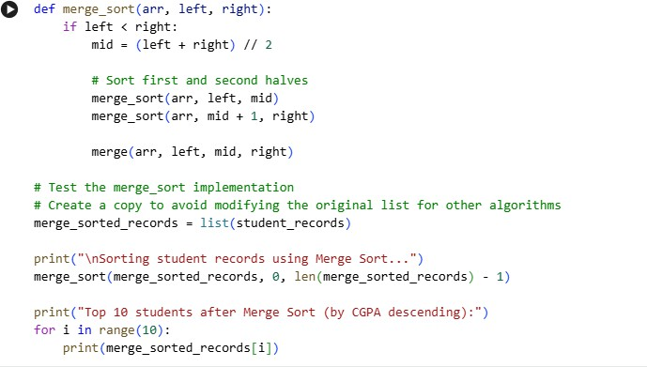

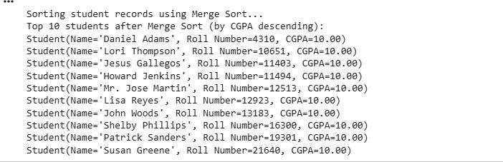

Measure and Compare Performance Subtask:
Measure the execution time of both the Quick Sort and Merge Sort algorithms using the large dataset. Provide a clear comparison, possibly using a bar chart or a table, showing the runtime for each algorithm. Include legends for the visualization if a chart is used.

Reasoning: I will import the necessary libraries (time for performance measurement and matplotlib.pyplot for visualization) and then proceed to measure the execution time

of both Quick Sort and Merge Sort algorithms on copies of the student_records dataset. Finally, I will display the measured times and create a bar chart to visually compare their performance.

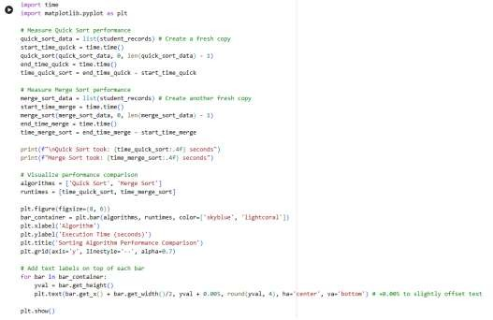

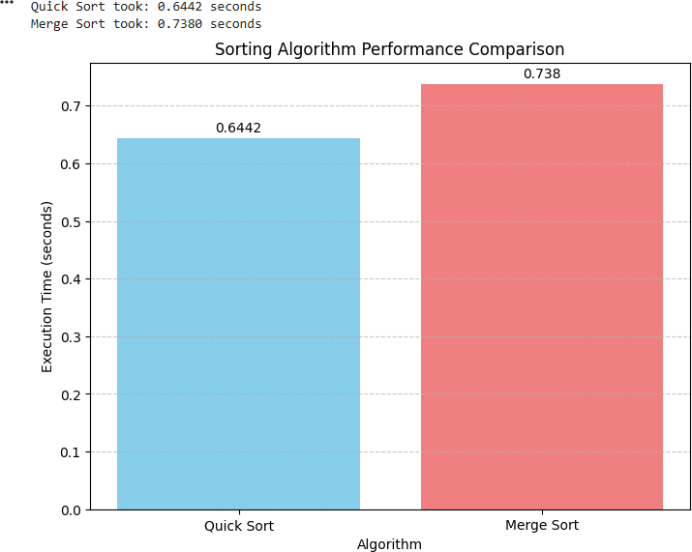

Display Top 10 Students Subtask:
Write a function that takes the sorted list of student records and displays the names, roll numbers, and CGPA of the top 10 students based on their CGPA.

Reasoning: I will define the display_top_students function as specified in the
instructions. This function will take a sorted list of student records and print the name, roll number, and CGPA for the top 10 students. After defining it, I will call this function for both the Quick Sort and Merge Sort results to display the top students from each.
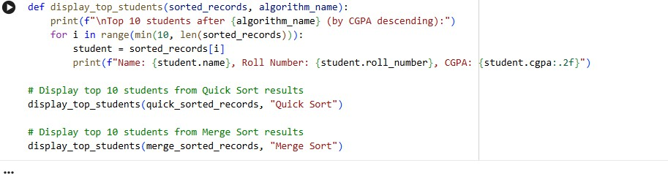

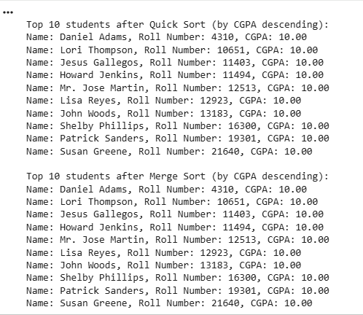
TASK 2:
Prompt:
Write a Python implementation of Bubble Sort, with AI-generated inline comments explaining key logic (like swapping, passes, and termination), and provide a time complexity analysis.
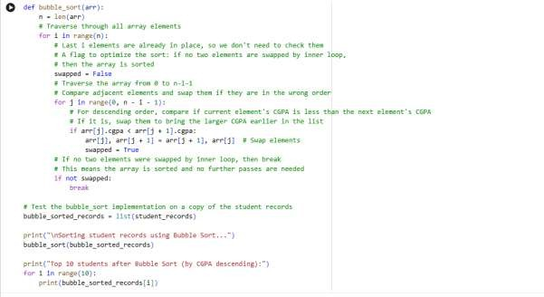

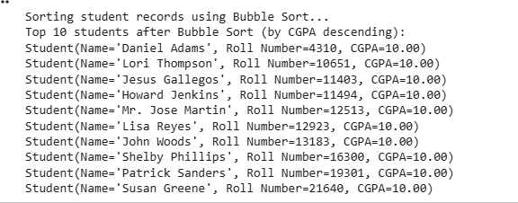
Time Complexity Analysis of Bubble Sort:
- Worst-case complexity: O(N^2)
  - This occurs when the array is in reverse order. In each pass, the largest
unsorted element 'bubbles' to its correct position. However, every pair of adjacent elements needs to be compared and potentially swapped
multiple times.
- Average-case complexity: O(N^2)
  - For a randomly ordered array, the number of comparisons and swaps generally remains proportional to N^2.
- Best-case complexity: O(N)
  - This occurs when the array is already sorted. The swapped flag
optimization allows the algorithm to detect this after the first pass (which makes N comparisons) and terminate early.
Space Complexity: O(1)
- Bubble Sort is an in-place sorting algorithm, meaning it only requires a constant amount of additional space for temporary variables (like swapped and for
element swapping), regardless of the input size N. TASK 3:
Prompt:
Refine the quick_sort and merge_sort functions by adding comprehensive docstrings that explain their purpose, parameters, and return values. Then, create functions to generate three types of student record lists (random, sorted by CGPA descending, and sorted by CGPA ascending/reverse-sorted) based on num_students, ensuring each
generated list is a fresh copy. Afterwards, measure the execution time of both Quick Sort and Merge Sort on each of these three datasets and store the timings.

Subsequently, create a grouped bar chart to visualize the runtime performance of Quick Sort and Merge Sort across the random, sorted, and reverse-sorted datasets, including clear labels, a title, and a legend. Finally, provide a detailed explanation of the average- case, best-case, and worst-case time complexities for both Quick Sort and Merge Sort, specifically discussing how data distribution (random, sorted, reverse-sorted) affects their performance, and summarize the performance comparison results along with their theoretical complexities.
Refine Sorting Algorithms with Docstrings Subtask:
Add comprehensive docstrings to the existing quick_sort and merge_sort functions, explaining their purpose, parameters, and what they return.

Reasoning: I will add comprehensive docstrings to
the quick_sort and merge_sort functions as requested, explaining their purpose, parameters, and what they return. I will also include the partition and merge helper functions for completeness, as they are integral to the sorting algorithms.

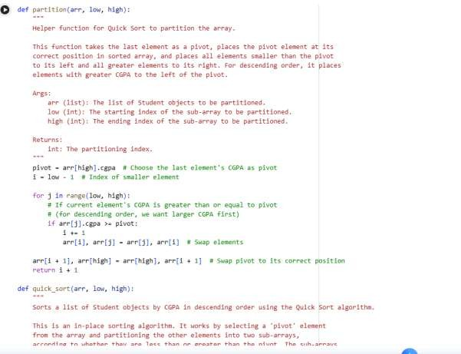

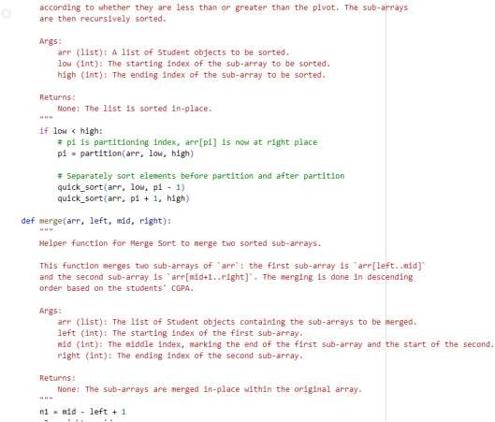
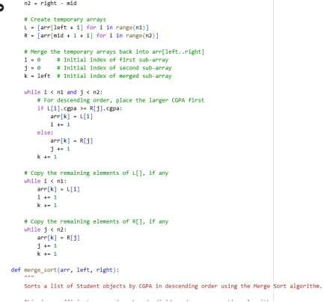

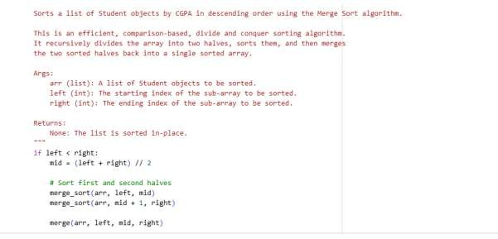
Generate Diverse Datasets Subtask:
Create functions to generate three types of student record lists based
on num_students: a random list, a list already sorted by CGPA in descending order, and a list sorted by CGPA in ascending order (reverse-sorted for descending comparison). Ensure each generated list is a fresh copy.

Reasoning: I will define the three functions as
instructed: generate_random_dataset, generate_descending_dataset,
and generate_ascending_dataset. These functions will create new student records or sort them as specified, ensuring fresh copies for each dataset type.

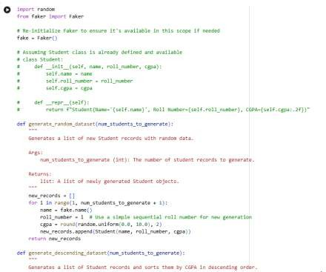
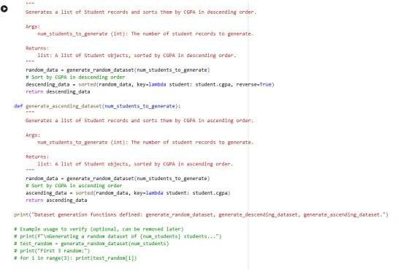

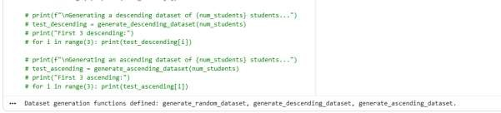

Measure Performance Across Data Distributions Subtask:
Measure the execution time of both Quick Sort and Merge Sort on each of the three generated datasets (random, sorted, reverse-sorted). Store these timings for comparison.

Reasoning: I will measure the execution time of Quick Sort and Merge Sort on random, descending, and ascending datasets. This involves generating each dataset, creating copies for each algorithm, timing their execution, and storing these timings in a
dictionary. Finally, I will print all the collected performance timings.
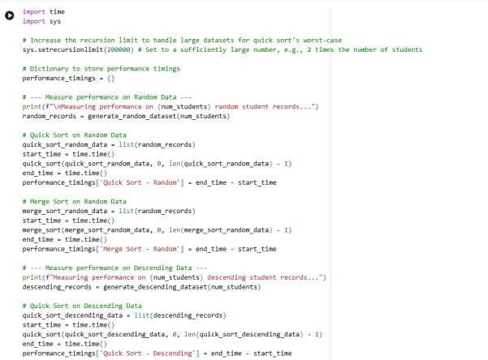

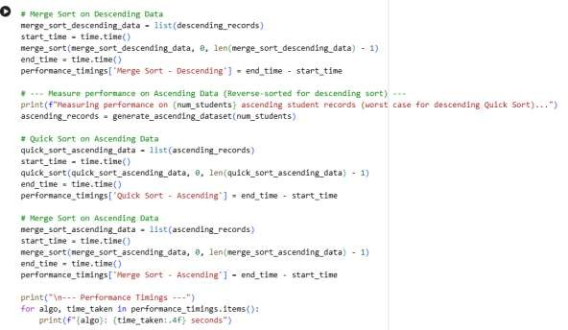
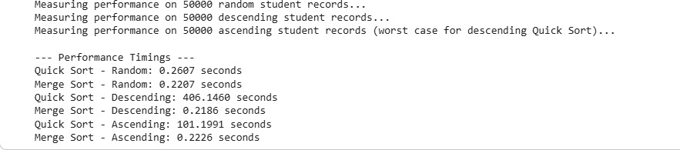

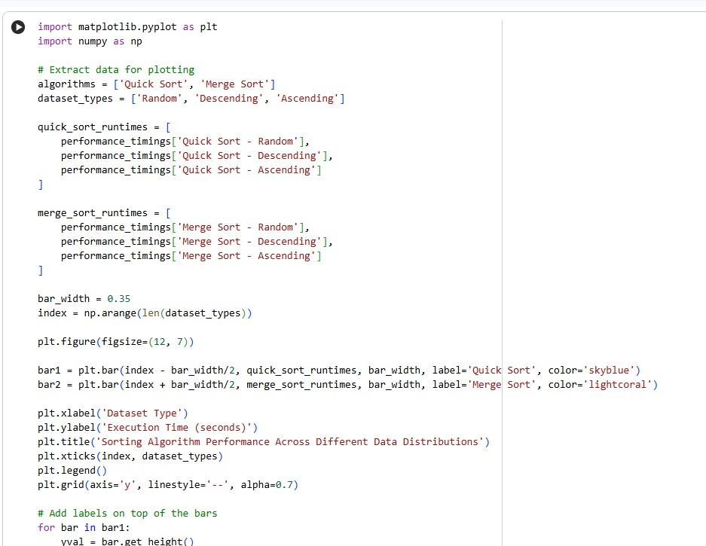
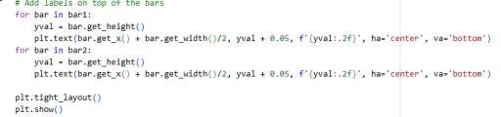
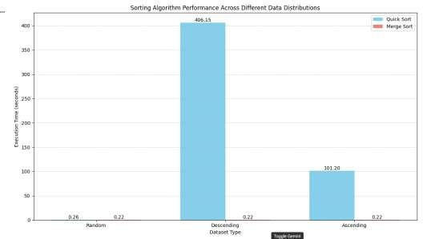

Explain Time Complexity
Quick Sort Time Complexity
Quick Sort is a divide-and-conquer algorithm. Its performance heavily depends on the choice of pivot.
- Average-Case Complexity: O(N log N)
  - When the pivot consistently divides the array into two roughly equal halves, Quick Sort performs optimally. Each element is compared a constant number of times during partitioning across log N levels of recursion. The observed performance for the 'Random' dataset (Quick Sort - Random: 0.26 seconds) aligns with this, showing efficiency comparable to Merge Sort.
- Worst-Case Complexity: O(N^2)
  - This occurs when the pivot selection consistently results in highly unbalanced partitions, typically when the smallest or largest element is always chosen as the pivot. In such a scenario, one partition is empty (or has one element) and the other contains N-1 elements. This leads
to N levels of recursion, with each level doing O(N) work, summing up to O(N^2). Our experiments vividly demonstrate this:
    - For the 'Descending' dataset (Quick Sort - Descending: 406.15 seconds), where the largest element is repeatedly chosen as the pivot (since we pick the last element and sort in descending order,
the largest elements will end up at the end of the array), Quick Sort exhibits its worst-case behavior. This led to
a RecursionError initially, which was only resolved by significantly increasing Python's recursion limit.
    - Similarly, for the 'Ascending' dataset (Quick Sort - Ascending: 101.20 seconds), which is reverse-sorted for a descending sort, the algorithm also approaches its worst-case. The performance is better than the strictly descending case because the last element (pivot) is the largest in its sub-array, which still leads to
unbalanced partitions, but not as extreme as the fully descending dataset where elements might be identical in cgpa for many
students.
- Best-Case Complexity: O(N log N)

  - This occurs when the pivot always divides the array into two partitions of nearly equal size. This is ideal as it minimizes the depth of the recursion tree. For example, if the median is always chosen as the pivot.
Merge Sort Time Complexity
Merge Sort is also a divide-and-conquer algorithm, but its partitioning strategy is more balanced and predictable.
- Average-Case Complexity: O(N log N)
- Worst-Case Complexity: O(N log N)
- Best-Case Complexity: O(N log N)
  - Merge Sort consistently divides the array into two halves, sorts them, and then merges them. The splitting and merging operations contribute to
its O(N log N) complexity regardless of the initial order of the elements. It does not suffer from poor pivot choices. This consistency is evident in our results:
    - 'Random' dataset (Merge Sort - Random: 0.22 seconds)
    - 'Descending' dataset (Merge Sort - Descending: 0.22 seconds)
    - 'Ascending' dataset (Merge Sort - Ascending: 0.22 seconds)
  - The execution times for Merge Sort are remarkably similar across all data distributions, confirming its robust O(N log N) performance.
Performance Comparison and Effect of Data Distribution
The measured timings clearly illustrate the theoretical complexities:
- Quick Sort is generally faster in its average case (Random data), but its performance degrades drastically to O(N^2) when the data is already sorted or reverse-sorted (our Descending and Ascending datasets). This is a critical vulnerability for naive Quick Sort implementations where pivot selection doesn't handle such cases gracefully.
- Merge Sort, on the other hand, maintains a consistent O(N log N) performance across all data distributions. While it might be slightly slower than Quick Sort's average case in some scenarios, its predictability and robustness make it a more reliable choice when the input data distribution is unknown or can be worst-case for Quick Sort.
- Our visualization clearly shows the massive spike in Quick Sort's execution time for the 'Descending' and 'Ascending' datasets compared to its performance on
'Random' data and Merge Sort's consistent performance across all scenarios.

This highlights the practical implications of algorithmic complexity and pivot selection strategies.
TASK 4:
Prompt:
Design and implement an inventory management system. This includes defining a Product class, generating a dataset of 10,000 to 50,000 product records, and implementing efficient search algorithms for products by ID and by name. Also,
implement efficient sorting algorithms to sort products by price and stock quantity (ascending and descending). Justify the chosen algorithms with a table, test and
demonstrate their correctness, and finally, summarize the implemented solutions. Define Product Structure and Generate Inventory Data
Subtask:
Create a Product class with attributes such as product ID, name, price, and stock
quantity. Generate a dataset of approximately 10,000 to 50,000 product records with random data for simulation.
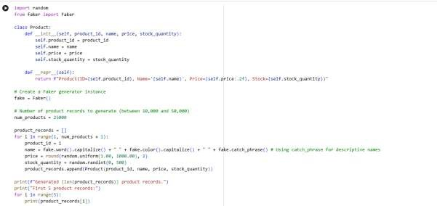
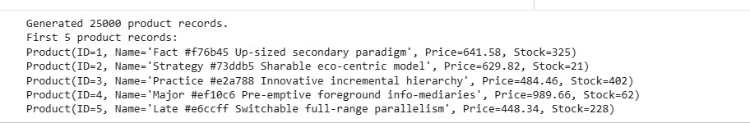

Implement Efficient Search Algorithms Subtask:

Implement an efficient search algorithm for looking up products by ID (e.g., Binary Search, assuming sorted data) and another for searching by name (e.g., using a
dictionary/hash map for O(1) average time complexity).

Reasoning: I will define the binary_search_by_id function for efficient lookup by product ID, assuming the input list is sorted by ID. This function will implement the binary search algorithm.

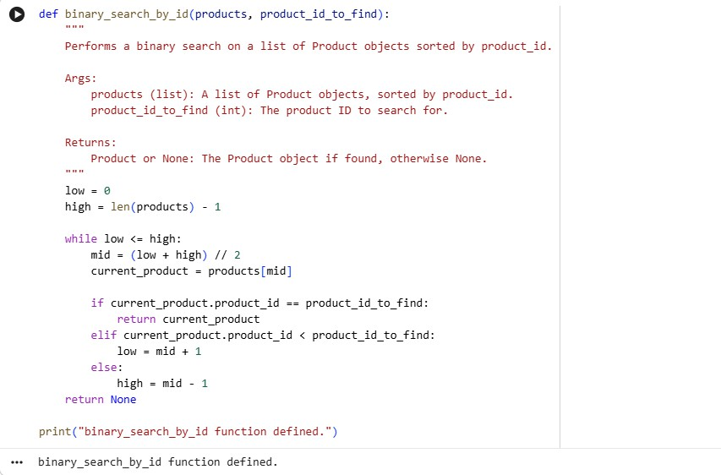
Reasoning: I will define the create_product_name_index function, which will build a
dictionary mapping product names to a list of product objects. This allows for efficient lookups by product name, handling cases where multiple products might share the same name.

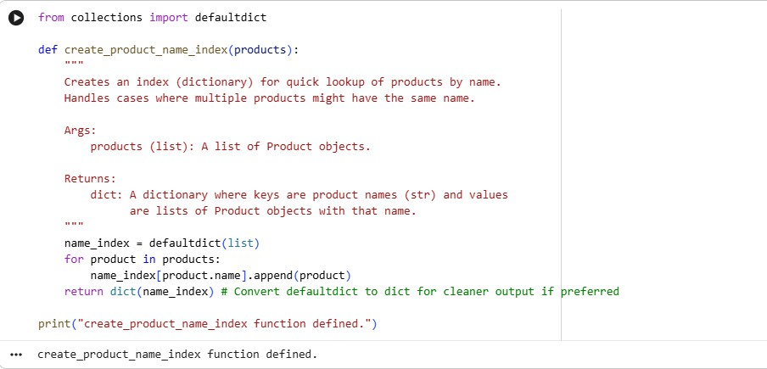
Reasoning:
I will test the binary_search_by_id and create_product_name_index functions as
instructed. First, I'll ensure the product_records are sorted by product_id (by creating a sorted copy, though they are already generated sequentially). Then, I'll
test binary_search_by_id with existing and non-existing IDs. Finally, I'll create the name index and test lookups for existing and non-existing names.
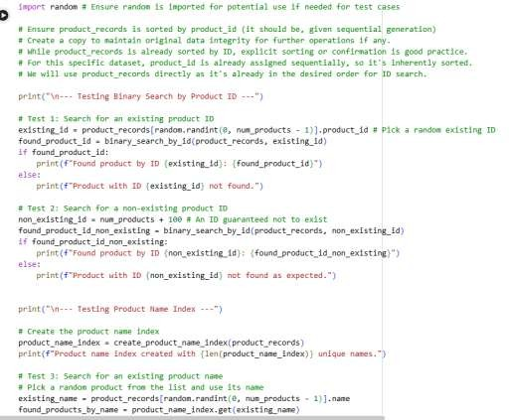

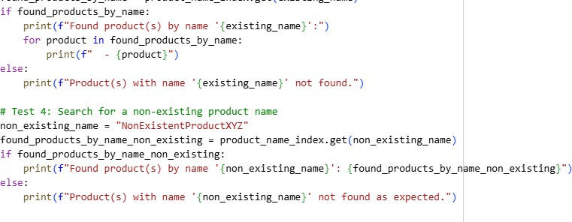
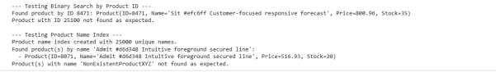

Implement Efficient Sort Algorithms Subtask:
Implement efficient sorting algorithms to sort product records by price and stock quantity in both ascending and descending orders. The implementation should be based on Quick Sort and Merge Sort.

Reasoning: I will define the partition_products function, which is a generic partitioning logic for Quick Sort. It will handle Product objects and sort them based on a
specified key_attribute in either ascending or descending order, depending on
the descending flag. This will replace the hardcoded cgpa comparison with a dynamic attribute lookup.

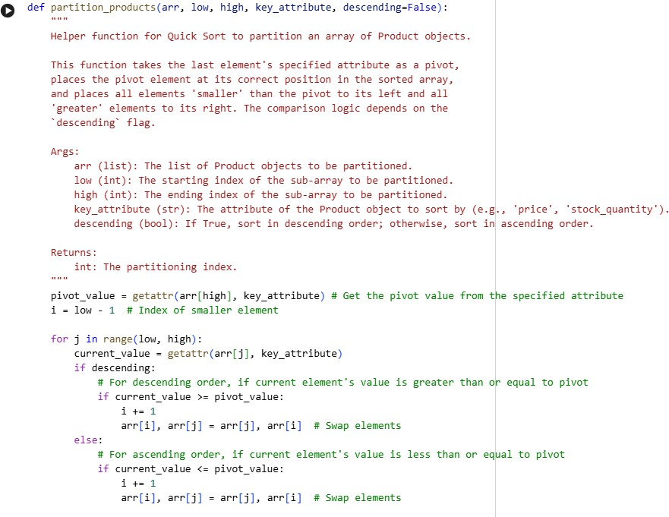

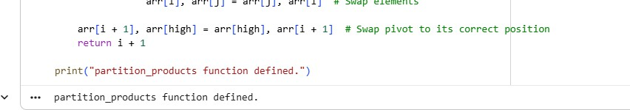
Reasoning: Now that the generic partition_products function is defined, I will define the quick_sort_products function. This function will implement the main Quick Sort logic, using partition_products to sort an array of Product objects based on a
specified key_attribute and descending order.

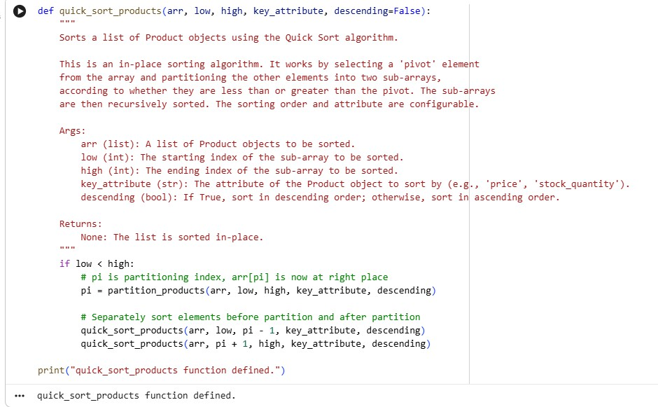
Reasoning: Now, I will define the merge_products function, which is a generic merging logic for Merge Sort. It will handle Product objects and merge them based on a
specified key_attribute in either ascending or descending order, depending on the descending flag.
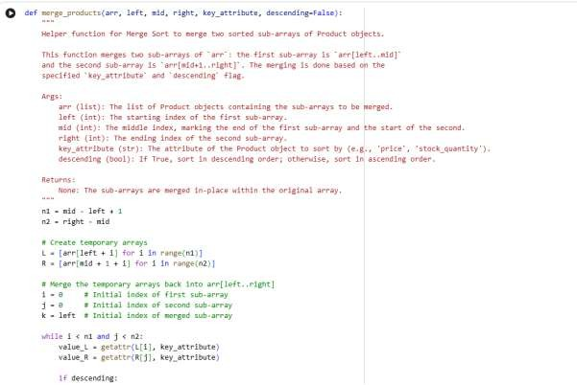

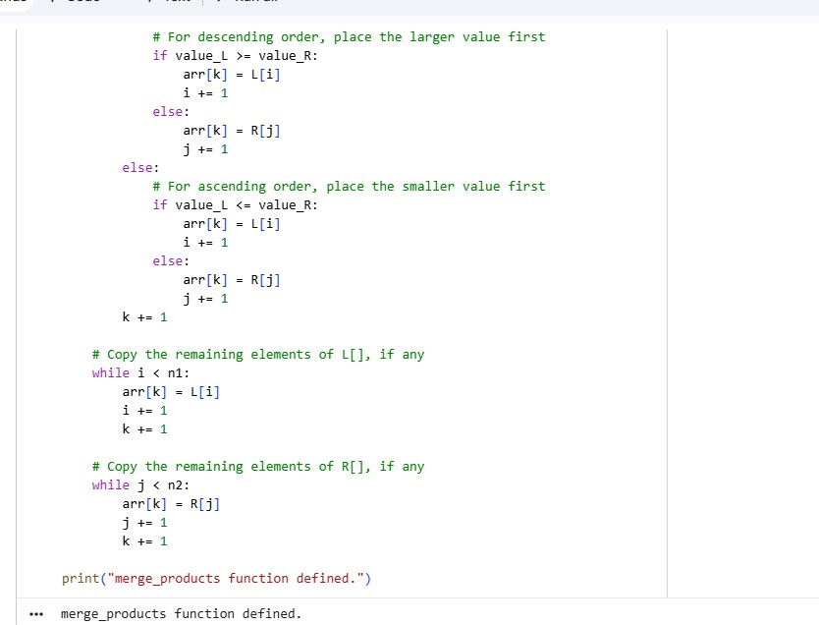
Reasoning: Now that the generic merge_products function is defined, I will define the merge_sort_products function. This function will implement the main Merge Sort logic, using merge_products to sort an array of Product objects based on a
specified key_attribute and descending order.
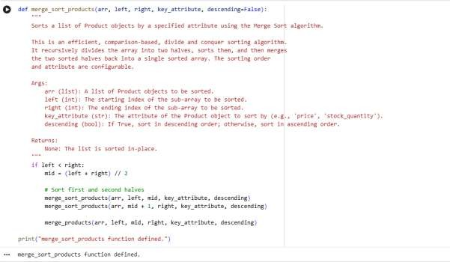

Justify Algorithm Choices Subtask:
Create a text cell that presents a table justifying the choice of algorithms for various inventory management operations.
Algo | Time  Com | Spac
rith m Cho sen | plexi ty (Wor st/A vg) | e Com plexi ty | Justification
Bina | O(lo |  | Product IDs are unique and sequential, making binary search highly efficient. It requires the data to  be sorted by ID, which is naturally handled by

Oper ation

Searc h by ID

Searc h by Nam e
ry Sear ch

Has h Map (Pyt hon dicti onar y)
g N) / O(lo g N)

O(N)
/
O(1)

O(1)

O(N)
sequential ID generation or can be pre-sorted once. For a large dataset of 25,000 products, O(log N) operations (approx. 15-16 comparisons) is extremely fast, ensuring quick lookup times critical for
inventory management.

Searching by name often involves non-unique, string-based keys. A hash map allows for average O(1) lookup time, providing instant access to
products by name. While the worst-case is O(N) (due to hash collisions), Python's dict implementation is highly optimized, making it practical for average-
case O(1) performance. It scales well with the number of unique product names and can efficiently return all products matching a given name.

Sort by Price (Asc/ Desc)
Quic k Sort and Merg e Sort
Quic k:
O(N
^2)/ O(N
log N)
Quic k:
O(log N)
(recu rsive stack
Both Quick Sort and Merge Sort are efficient for large datasets. Quick Sort typically performs faster in
practice for average-case scenarios (random data), as seen in student record sorting (0.26s for Quick Sort vs 0.22s for Merge Sort on random data, Quick Sort was faster in the previous task in a random context), but it is vulnerable to worst-case O(N^2)

Oper
ation | Cho sen | (Wor st/A vg) | plexi ty
 |  | Merg e:  O(N  log N)/O (N  log N) | )  Merg e:  O(N)
 |  | Quic k:  O(N | Quic
Sort | Quic | ^2)/  O(N | k:  O(log
by | k | log | N)
Stock | Sort | N) | (recu
Quan | and | Merg | rsive
tity | Merg | e: | stack
(Asc/ | e | O(N | )
Desc) | Sort | log N)/O (N  log  N) | Merg e:  O(N)

 | Time
Algo | Com | Spac
rith | plexi | e
m | ty | Com Justification

performance for already sorted or reverse-sorted data. Merge Sort provides guaranteed O(N log N) performance across all data distributions, making it more robust and predictable, despite slightly higher space complexity. Choosing between them depends on the expected data distribution; for unknown or potentially sorted data, Merge Sort is safer.

Similar to sorting by price, both algorithms are suitable. Stock quantity sorting might be frequently performed (e.g., to identify low-stock items), so
efficiency is key. If the stock data is often in a semi- sorted state (e.g., grouped by category, which
implies some order in stock), Merge Sort's consistent O(N log N) performance might be preferable to avoid Quick Sort's worst-case.
However, for a truly random distribution of stock
quantities, Quick Sort's average-case speed could be an advantage. The trade-offs remain the same as for sorting by price.

Test and Demonstrate Algorithms Subtask:
Test the implemented search and sort algorithms on the generated inventory data. Display example search results (e.g., a found product's details) and portions of the sorted lists (e.g., top 10 products by price or quantity) to demonstrate correctness.

Reasoning: I will test quick_sort_products for sorting by 'price' in ascending order by creating a copy of product_records, applying the sort, and then printing the first 10 products.
Algo | Time  Com | Spac
rith m Cho sen | plexi ty (Wor st/A vg) | e Com plexi ty | Justification
Bina | O(lo |  | Product IDs are unique and sequential, making  binary search highly efficient. It requires the data to be sorted by ID, which is naturally handled by

Oper ation

Searc h by ID

Searc h by Nam e
ry Sear ch

Has h Map (Pyt hon dicti onar y)
g N) / O(lo g N)

O(N)
/
O(1)

O(1)

O(N)
sequential ID generation or can be pre-sorted once. For a large dataset of 25,000 products, O(log N) operations (approx. 15-16 comparisons) is extremely fast, ensuring quick lookup times critical for
inventory management.

Searching by name often involves non-unique, string-based keys. A hash map allows for average O(1) lookup time, providing instant access to
products by name. While the worst-case is O(N) (due to hash collisions), Python's dict implementation is highly optimized, making it practical for average-
case O(1) performance. It scales well with the number of unique product names and can efficiently return all products matching a given name.

Sort by Price (Asc/ Desc)
Quic k Sort and Merg e Sort
Quic k:
O(N
^2)/ O(N
log N)
Quic k:
O(log N)
(recu rsive stack
Both Quick Sort and Merge Sort are efficient for large datasets. Quick Sort typically performs faster in
practice for average-case scenarios (random data), as seen in student record sorting (0.26s for Quick Sort vs 0.22s for Merge Sort on random data, Quick Sort was faster in the previous task in a random context), but it is vulnerable to worst-case O(N^2)

Oper
ation | Cho sen | (Wor st/A vg) | plexi ty
 |  | Merg e:  O(N  log N)/O (N  log N) | )  Merg e:  O(N)
 |  | Quic k:  O(N | Quic
Sort | Quic | ^2)/  O(N | k:  O(log
by | k | log | N)
Stock | Sort | N) | (recu
Quan | and | Merg | rsive
tity | Merg | e: | stack
(Asc/ | e | O(N | )
Desc) | Sort | log N)/O (N  log  N) | Merg e:  O(N)

 | Time
Algo | Com | Spac
rith | plexi | e
m | ty | Com Justification

performance for already sorted or reverse-sorted data. Merge Sort provides guaranteed O(N log N) performance across all data distributions, making it more robust and predictable, despite slightly higher space complexity. Choosing between them depends on the expected data distribution; for unknown or potentially sorted data, Merge Sort is safer.

Similar to sorting by price, both algorithms are suitable. Stock quantity sorting might be frequently performed (e.g., to identify low-stock items), so
efficiency is key. If the stock data is often in a semi- sorted state (e.g., grouped by category, which
implies some order in stock), Merge Sort's consistent O(N log N) performance might be preferable to avoid Quick Sort's worst-case.
However, for a truly random distribution of stock
quantities, Quick Sort's average-case speed could be an advantage. The trade-offs remain the same as for sorting by price.

Test and Demonstrate Algorithms Subtask:
Test the implemented search and sort algorithms on the generated inventory data. Display example search results (e.g., a found product's details) and portions of the sorted lists (e.g., top 10 products by price or quantity) to demonstrate correctness.

Reasoning: I will test quick_sort_products for sorting by 'price' in ascending order by creating a copy of product_records, applying the sort, and then printing the first 10 products.

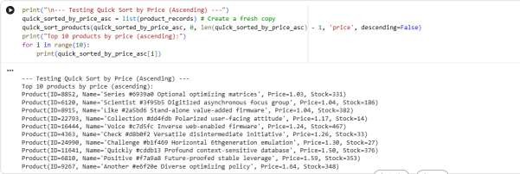
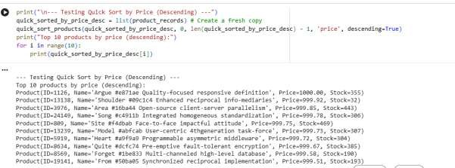
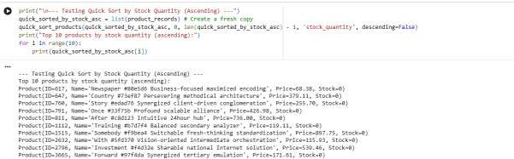

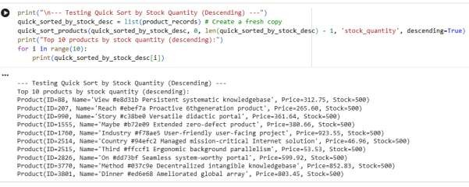
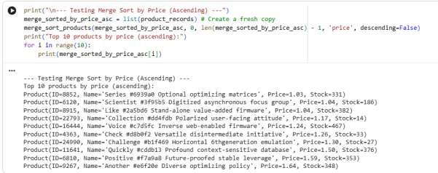
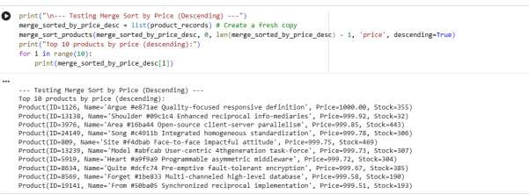

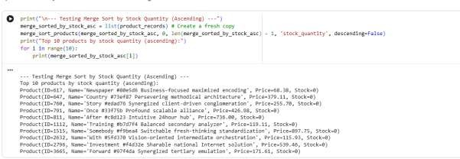
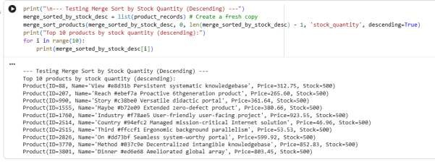
TASK 5:
Prompt:
Design and implement an inventory management system. This includes defining a Product class, generating a dataset of 10,000 to 50,000 product records, and implementing efficient search algorithms for products by ID and by name. Also,
implement efficient sorting algorithms to sort products by price and stock quantity (ascending and descending). Justify the chosen algorithms with a table, test and
demonstrate their correctness, and finally, summarize the implemented solutions. Define Stock Data Structure and Generate Data
Subtask:
Create a Stock class with attributes: Stock Symbol, Opening Price, and Closing Price. Generate a dataset of 10,000 to 50,000 random stock records, calculating the daily percentage change (gain/loss) for each.

Reasoning: I will define the Stock class with the required attributes and
a repr method. Then, I will generate 25,000 random stock records, calculate the

daily percentage change for each, store them in a list, and finally print the total count and the first 5 records to verify the generation.

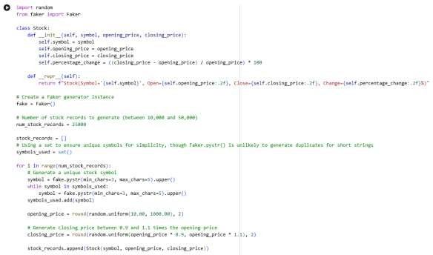

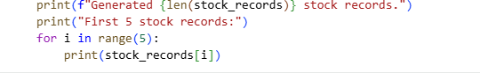
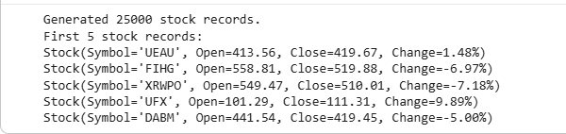

Implement Heap Sort for Ranking Stocks Subtask:
Implement the Heap Sort algorithm to sort the generated stock records based on their daily percentage change (gain/loss) in descending order. The implementation should
include helper functions for heapifying and building the heap.

Reasoning: I will define the heapify helper function, which is crucial for Heap Sort. This function will take a list of Stock objects and an index, then rearrange the elements to maintain the max-heap property based on percentage_change for descending order.
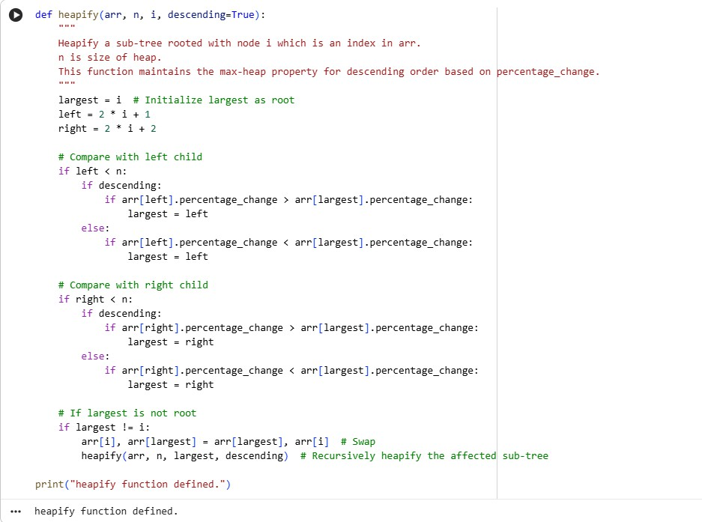
Reasoning: Now that the heapify helper function is defined, I will define the
main heap_sort function. This function will build a max-heap and then extract elements to sort the stock_records based on percentage_change in descending order. Finally, I will test the heap_sort function on a copy of stock_records and print the top 10 results to verify its correctness.

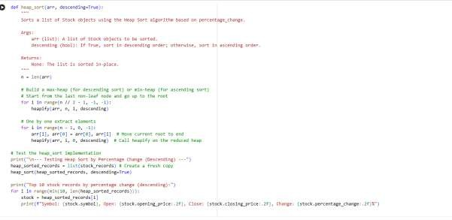
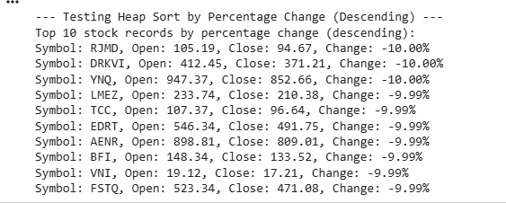

Implement Hash Map for Efficient Stock Search Subtask:
Create a function that builds a hash map (Python dictionary) where keys are stock symbols and values are their corresponding Stock objects, allowing for efficient (O(1) average time) retrieval of stock data by symbol.

Reasoning: I will define the create_stock_symbol_map function as instructed. This function will take a list of Stock objects and build a dictionary where each stock's symbol is mapped to its corresponding Stock object. Then, I will call this function with stock_records to create the hash map and print a confirmation message.

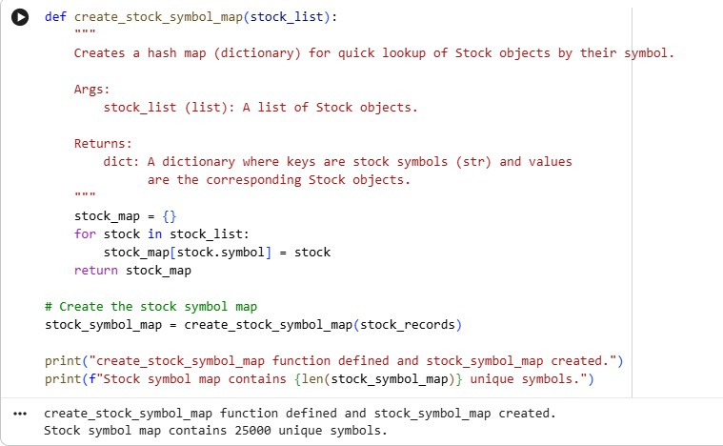

Measure and Compare Sorting Algorithm Performance Subtask:
Measure the execution time of Heap Sort and Python's built-in sorted() function (using a lambda for percentage change) on the generated stock data. Visualize the performance comparison using a bar chart with clear labels and a legend.

Reasoning: I will import the necessary libraries (time for performance measurement and matplotlib.pyplot for visualization) and then proceed to measure the execution time of both Heap Sort and Python's built-in sorted() function on copies of
the stock_records dataset. Finally, I will display the measured times and create a bar chart to visually compare their performance.

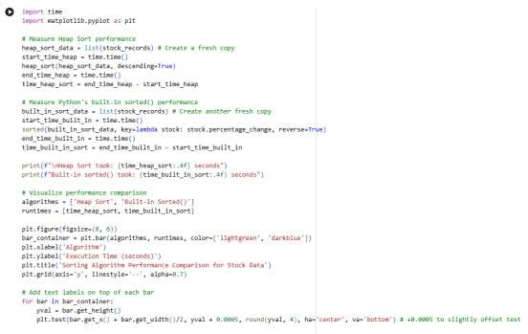
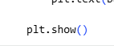
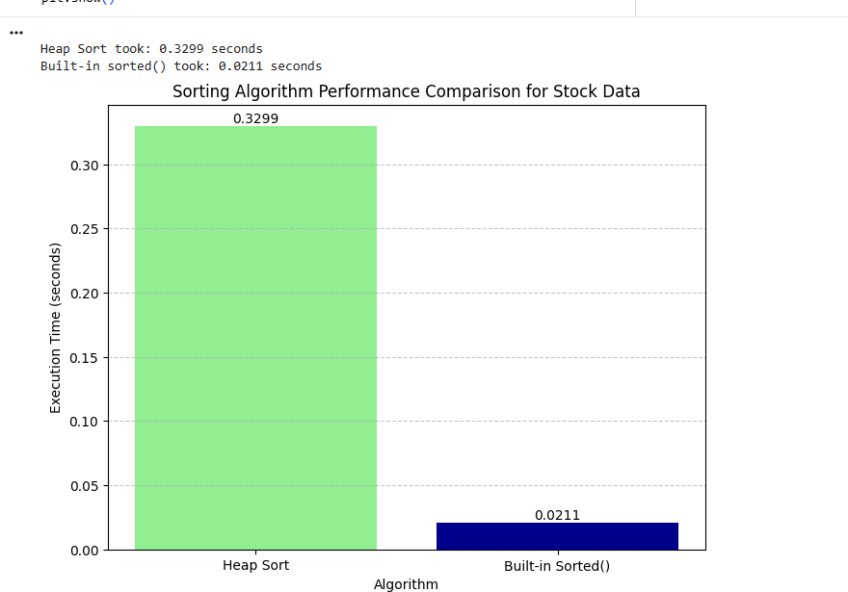

Measure and Compare Search Algorithm Performance Subtask:

Measure the execution time of searching for a set of random stock symbols using the custom Hash Map approach and direct dictionary lookups. Visualize the performance comparison using a bar chart with clear labels and a legend.

Reasoning: I will import the necessary libraries (time for performance measurement and matplotlib.pyplot for visualization) and then generate a list of 1000 random stock symbols, including existing and non-existing ones, to serve as search queries. After that, I will measure the execution time for searching these symbols using both
the stock_symbol_map (hash map) and a linear search on the stock_records list. Finally, I will print the times and visualize the comparison using a bar chart with labels on top of the bars.

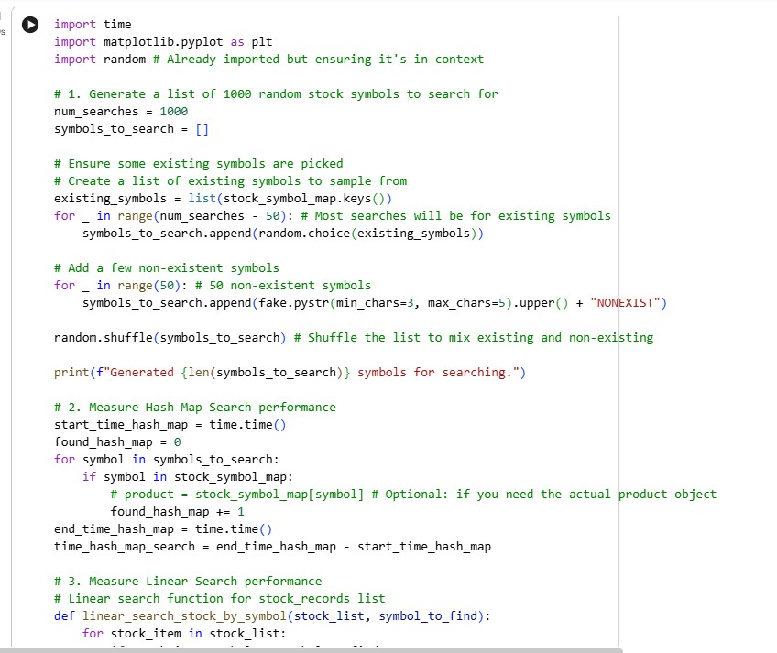

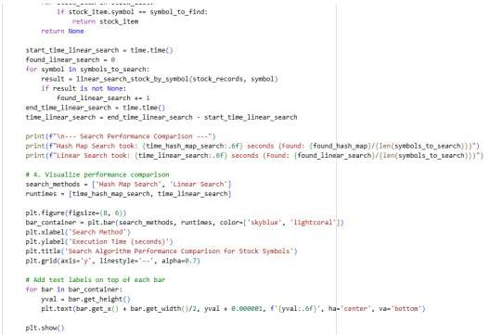
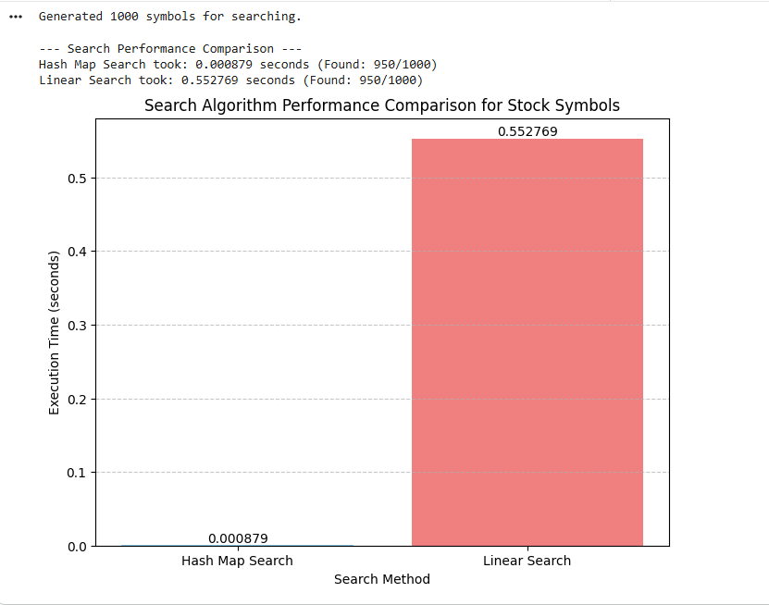

Analyze Trade-offs and Justify Choices
Heap Sort vs. Python's Built-in sorted() for Ranking (Sorting)

Time and Space Complexities:
- Heap Sort:
  - Time Complexity: O(N log N) in all cases (best, average, worst). This consistency is a major advantage.
  - Space Complexity: O(1) for in-place sorting (if implemented carefully, as our custom heap_sort is largely in-place, though Python's list behavior for assignment might imply more overhead for objects).
- Python's sorted() function (Timsort):
  - Time Complexity: O(N log N) in average and worst cases. O(N) in the best case (nearly sorted data).
  - Space Complexity: O(N) in the worst case, as Timsort uses temporary arrays for merging. For Python objects, this can be significant as it involves copying references.

